Md. Shakil Ahmed

Roll-2013

Case-02

Answer-01:

Nmap (Network Mapper) is an open-source tool designed for network exploration and security auditing. It helps network administrators and security professionals discover devices on a network, identify open ports, and detect services running on those ports. Here are some key features of Nmap:

1. **Host Discovery**: Identify which devices are active on a network.
2. **Port Scanning**: Check for open ports on a target device, helping to assess security.
3. **Service Version Detection**: Determine what services are running on open ports and their versions.
4. **OS Detection**: Guess the operating system of the target devices.
5. **Scriptable Interaction**: Nmap includes a scripting engine (NSE) that allows users to write scripts for advanced scanning and automation tasks.

Nmap is widely used in cybersecurity assessments and network management, making it a valuable tool for anyone working in IT security.

**Answer-02:**

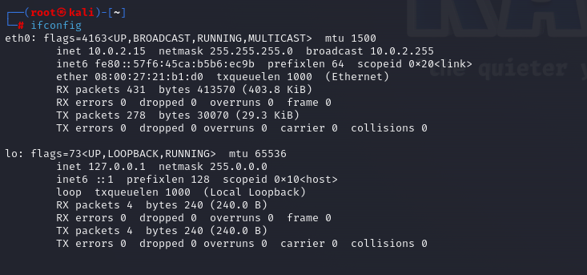

**Answer-03:**

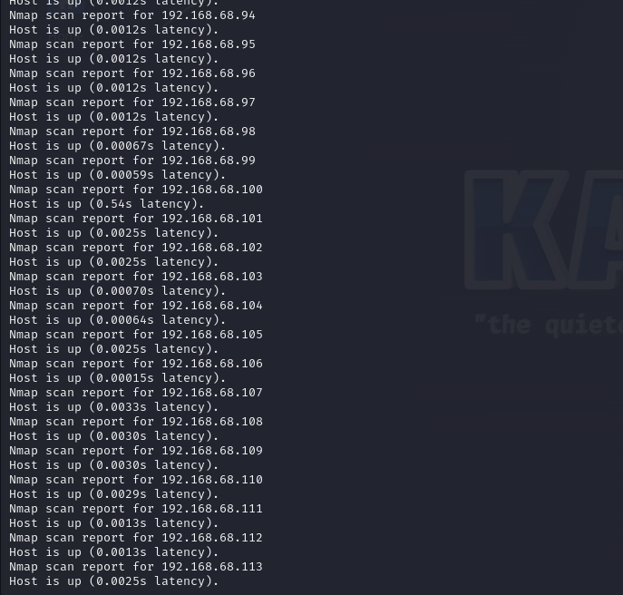

**Answer-04:**

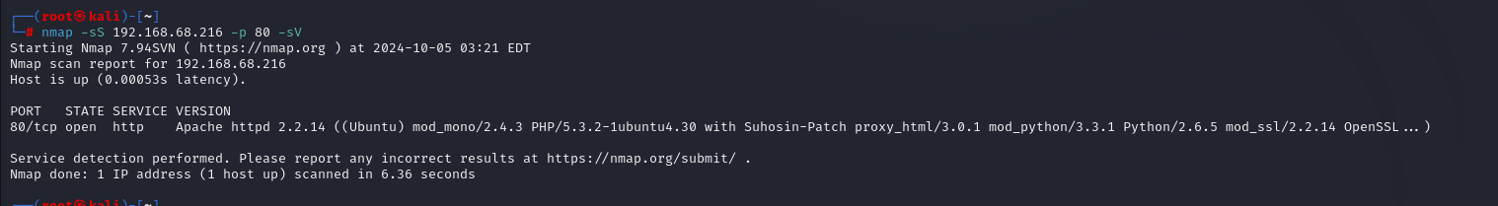

**Answer-05:**

